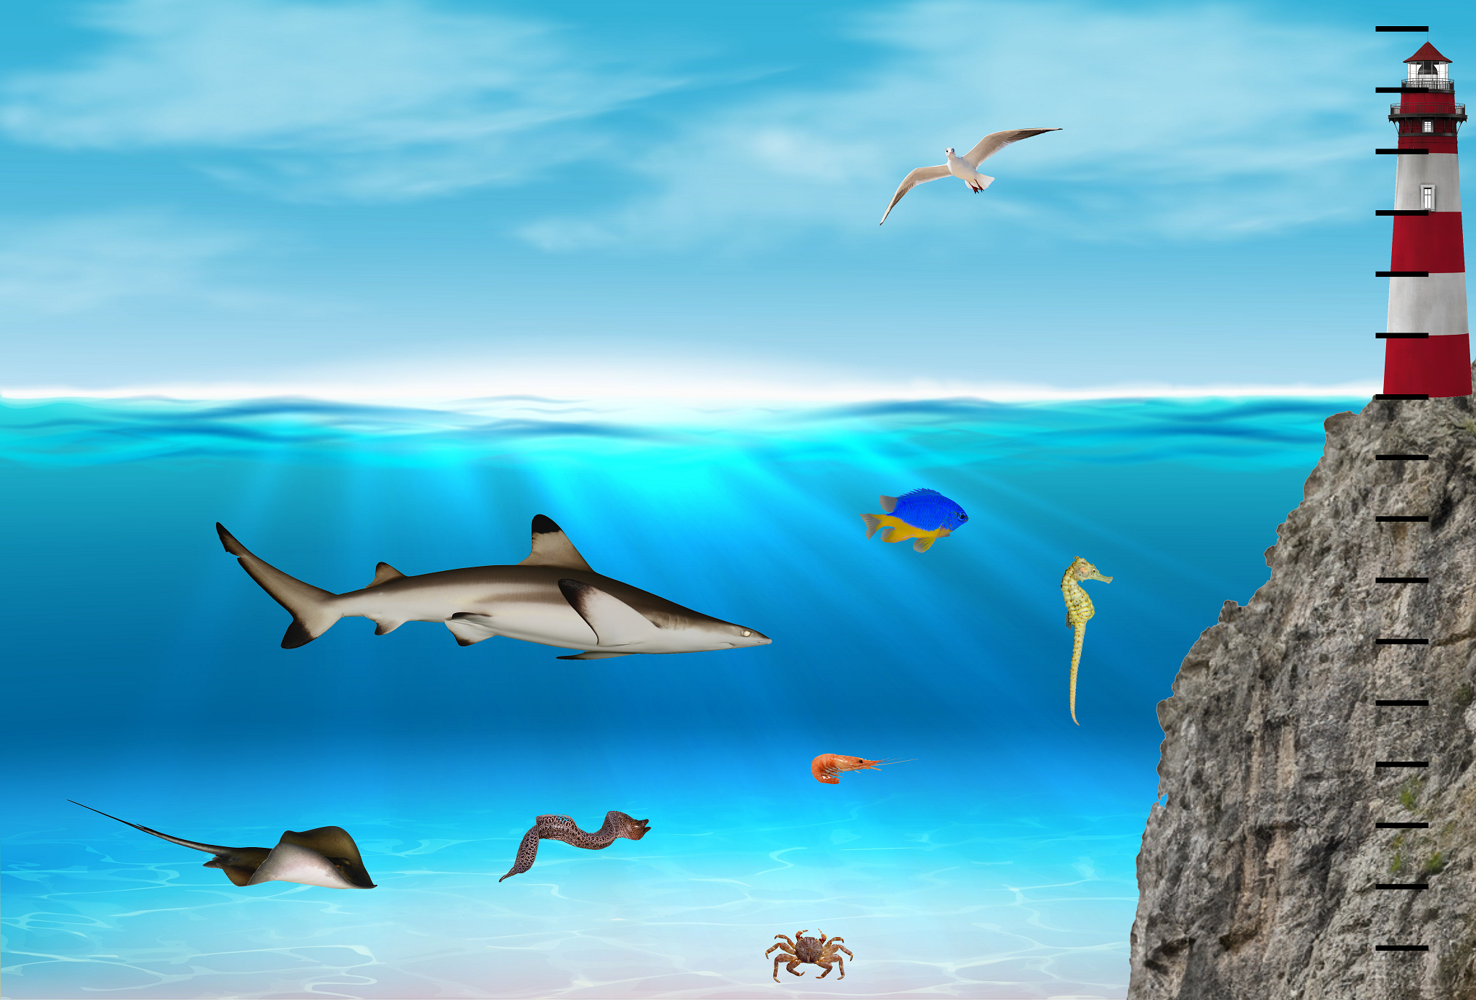
What can you see in the picture?
There are black markings all the way up the lighthouse right to the very top, and on the rock that the lighthouse is built on, going down to the sea bed. These markings are 1 metre apart.
We will call sea level '0' and then we could think of the lines as representing positive numbers going upwards and negative numbers going down to the sea bed.
In this task, we are going to look at where the mouths of each of the different animals are. This will allow us to see how deep they are compared to each other, or what distance apart they are.
For example, the seahorse's mouth is 1 metre deeper than the mouth of the blue and yellow fish.
Have a think about these questions, or you might like to make up some of your own:
- What number should be where the head of the seagull is?
- What number should be where the mouth of the crab is?
- How far up is it from the head of the shrimp to the mouth of the shark?
- How far from the surface is the eel's mouth?
- How high above the sea level is the seagull's beak?
- How much higher is the seagull's beak than the seahorse's mouth?
How did you arrive at your answers? Did you write anything down to help you?

