A First Product Sudoku

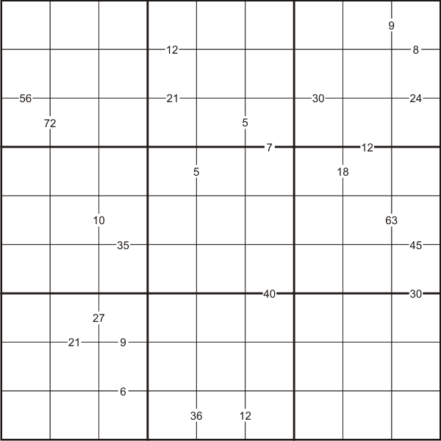

Like the standard Sudoku, this Sudoku consists of a grid of nine rows and nine columns subdivided into nine 3x3 subgrids.
Like the standard Sudoku, it has two basic rules:
1. Each column, each row and each box (3x3 subgrid) must have the numbers 1 to 9
2. No column, row or box can have two squares with the same number.
The puzzle can be solved with the help of clue-numbers which are small numbers written on the intersections between two cells. Each clue-number is the product of the two digits in the two cells that are on either side of it.
For example, 8 in the top right box means that possible pairs of numbers for the cell in row 1, column 9 and the cell in row 2, column 9 are either 1 and 8, 8 and 1; 4 and 2, or 2 and 4 respectively.

