This game is for two players.
You will need to draw a number line from -13 to 13 on a piece of paper, and find a counter and two 1-6 dice to use.
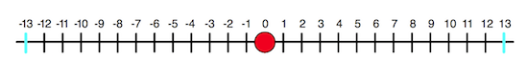
Decide who is Positive and who is Negative.
Positive moves the counter from left to right and Negative moves the counter from right to left. (Why do you think we have suggested this way round?)
Place the counter on 0 (the picture above shows a red counter).
Take it in turns to throw the two dice and add the scores then move the counter that number of places in your direction.
If the counter reaches -13, Negative has won. If the counter reaches 13, Positive has won.
Is it better to play a game where you have to reach the end exactly, or where you can go over the end? What do you think and why?
Now change the game. This time, when you throw the dice, you can decide whether to add, subtract, multiply or divide the numbers on the dice. You must reach -13 or 13 exactly to win.
Does this make a better game? What do you think? Why or why not?
How else could you change the game?

