In this game the winner is the first to complete a row of three, either horizontally, vertically or diagonally.
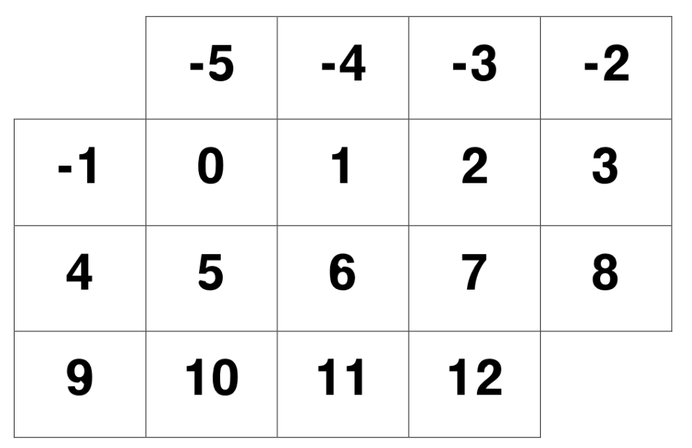

Roll two 1-6 dice and decide whether you want to add or subtract to produce a total shown on the board. Your total will then be covered with a counter.
You cannot cover a number which has already been covered.
If you are unable to find a total which has not been covered you must Pass.
Are there some numbers that we should be aiming for? Why?
Which number on the grid is the easiest to get? Why?
Which number is the most difficult to get? Why?

