In this first version of Connect Three, the winner is the first to complete a row of three, either horizontally, vertically or diagonally.
Roll the dice, choose what order to place the dice in, and add or subtract them to produce a total shown on the board, which you can then cover with one of your counters.
You cannot cover a number which has already been covered.
If you are unable to find a total which has not been covered you must Pass.

The winner is the first to complete a line of three.

Play the game a few times, and then take a look at the questions below.

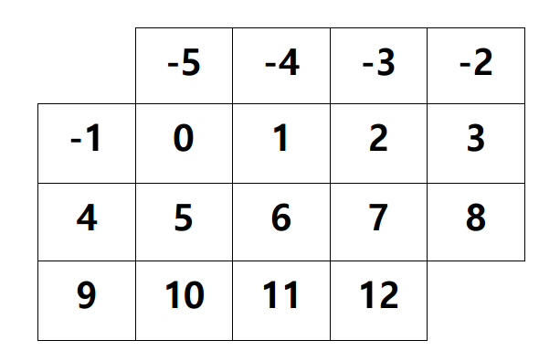

Which numbers belong to most winning lines?
Does this influence the way in which you might choose to play the game?

This second version of Connect Three is played with two special dice, one with the numbers 1, 2, 3, −4, −5, −6 and the other with the numbers
−1, −2, −3, 4, 5, 6.
Choose what order to place the dice in, and add or subtract them to produce one of the totals shown on the board, which you can then cover with one of your counters.
You cannot cover a number which has already been covered. If you are unable to find a total which has not been covered you must Pass.
The winner is the first to complete a line of three.
Play the game a few times, and then take a look at the questions below.

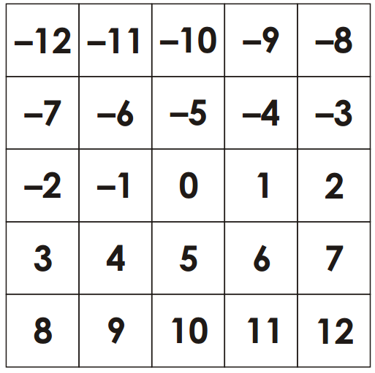

Some numbers can only be made in one way, but some can be made in many different ways.

Can you work out the number of different ways of achieving each of the different totals?
Does this influence the way in which you might choose to play the game?

