The game Connect Three is played with two spinners, one with the numbers 1, 2, 3, −4, −5, −6 and the other with the numbers
−1, −2, −3, 4, 5, 6.
Spin the two spinners, choose what order to place the numbers in, and add or subtract them to produce one of the totals shown on the board, which you can then cover with one of your counters.
Can you place three of your counters in a straight line before your opponent does?
Play the game a few times, and then take a look at the questions below.

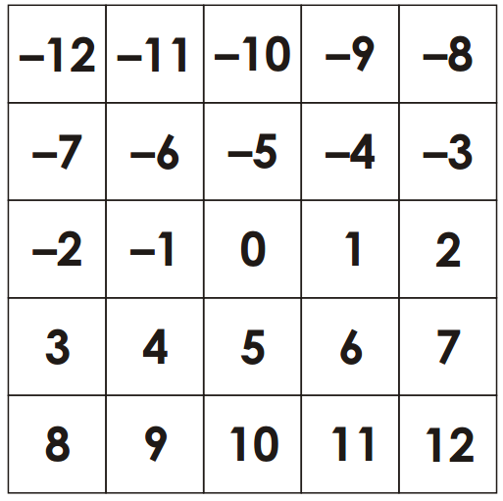

Some numbers can only be made in one way, but some can be made in many different ways.

Can you work out the number of different ways of achieving each of the different totals?
Does this influence the way in which you might choose to play the game?

