Choose a fraction to start from.
From your chosen fraction, can you find a sequence of twists and turns that get you back to zero? Remember, twisting:

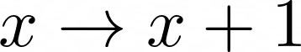
and turning:
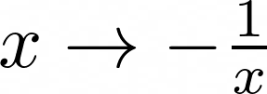
Perhaps you might like to start with a negative fraction containing a 2 as the denominator, such as 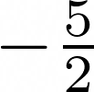 or 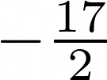 or 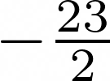
Can you find a way to get back to zero?
Try to describe an efficient strategy for disentangling any fraction of the form
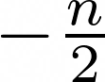
How does this help you get back to zero from a positive fraction with 2 as the numerator, such as 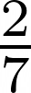 or 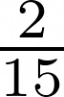 or 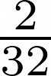?
Next, you could consider ropes that have been tangled up and have left you with a negative fraction containing a 3 as the denominator
e.g. 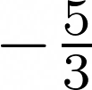 or 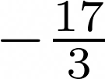 or 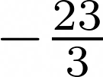
Try to describe an efficient strategy for disentangling any fraction of the form
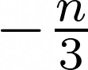

and use this to suggest a strategy for disentangling any fraction of the form
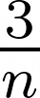

Next, you could consider ropes that have been tangled up and have left you with negative fractions containing 4,5,6…as the denominator, or positive fractions containing 4,5,6… as the numerator.
Can you develop a strategy for disentangling any tangled ropes, irrespective of the fraction you have ended up with?

