This problem introduces a trick that can be done with two skipping ropes. Two operations can be done: twisting and turning.

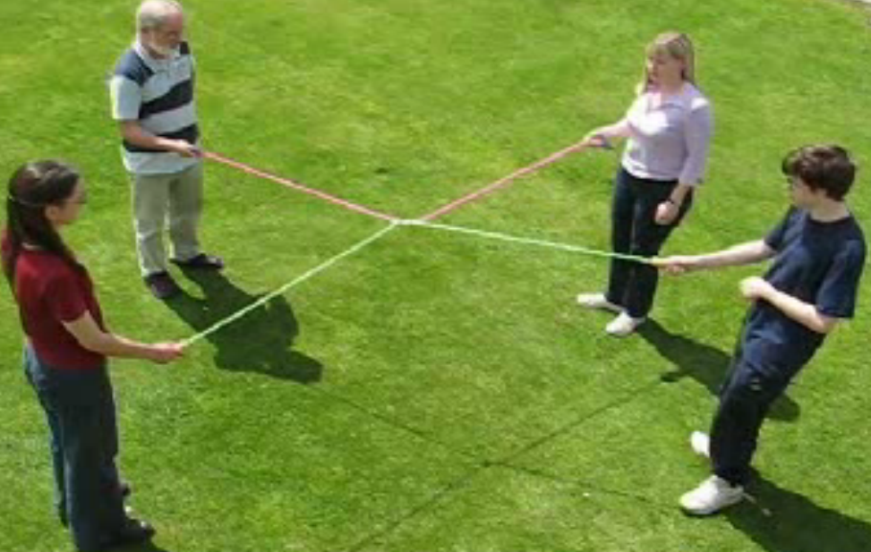
There is a video showing the operations at http://nrich.maths.org/5776.
Twisting has the effect of adding 1:
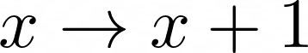
Turning transforms any number into the negative of its reciprocal:
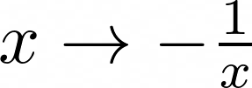

If the ropes are tangled like this:
Twist, twist, turn, twist, twist, twist, turn, twist, twist, twist, turn

Then this sequence of numbers is produced:

And the ropes can be disentangled like this:

Twist, turn, twist, twist, turn, twist, twist, twist, turn, twist, twist, twist

Generating these numbers:

Starting at zero (with both ropes parallel), what would you end with after the following sequence of moves?

Twist, twist, twist, turn, twist, twist, twist, turn, twist, twist, twist, turn

Can you find a sequence of moves that will take you back to zero?

