Name:

Each shape stands for one of these numbers:  0 1 2 3 4 5 6 8 9 10 12  With a partner, work out which number each shape represents and explain how you know.  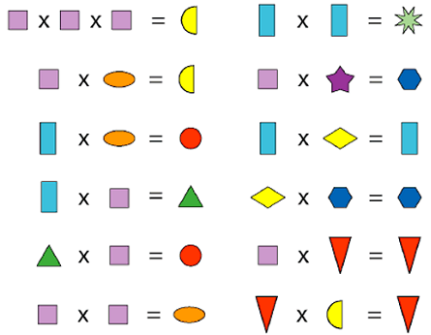  - Try starting with and  - Cross off numbers as you work them out | 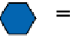 | because... | 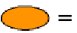 | because...
 | 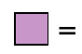 | because... | 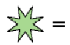 | because...
 | 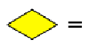 | because... | 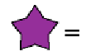 | because...
 | 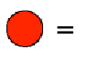 | because... | 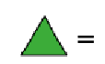 | because...
 | 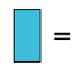 | because... | 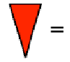 | because...
 | 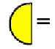 | because...

