If a sum invested gains 10% each year how long will it be before it has doubled its value?
If an object depreciates in value by 10% each year how long will it take until only half of the original value remains?
Why aren't these two answers the same?

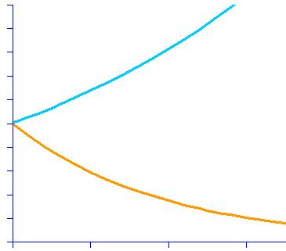
Is there a rate, used for both gain and depreciation, for which those two answers would actually be the same? How do you know?

