Draw a number line on a piece of paper, marked from 0 to 20, like this:
This challenge is a game for two players. The first player chooses two numbers in this grid and either multiplies or divides them.
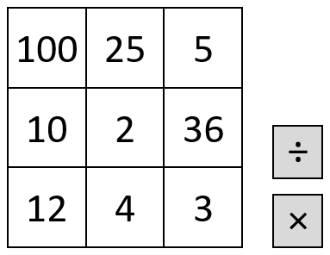
They then mark the answer to the calculation on the number line. The second player then chooses two numbers and either × or ÷, and marks that number in a different colour on the number line.
If the answer is too big or too small to be marked on the number line, the player misses a go.
The winner is the player to get four marks in a row with none of their opponent's marks in between.
What good ways do you have of winning the game?
Does it matter if you go first or second?

This game is adapted from a SMILE Centre card.

