Imagine the yellow dot travelling anticlockwise around the circle.

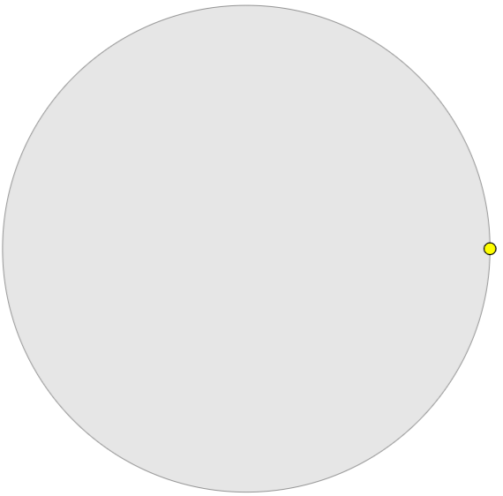

Now imagine the yellow dot starts at the point (1,0) (where it is shown in the diagram above), turns through 60 degrees anticlockwise and then stops.
I was wondering, if the point hadn't stopped, and instead carried on until it had turned through 30 000 degrees, might it have finished the same distance above the horizontal axis?
I took out my calculator and typed 30 000 ÷ 360.
The answer on the screen was 83.333333.
How can I use this to help me solve my problem?

