Imagine the dot starts at the point (1,0) and turns anticlockwise along the edge of the circle.

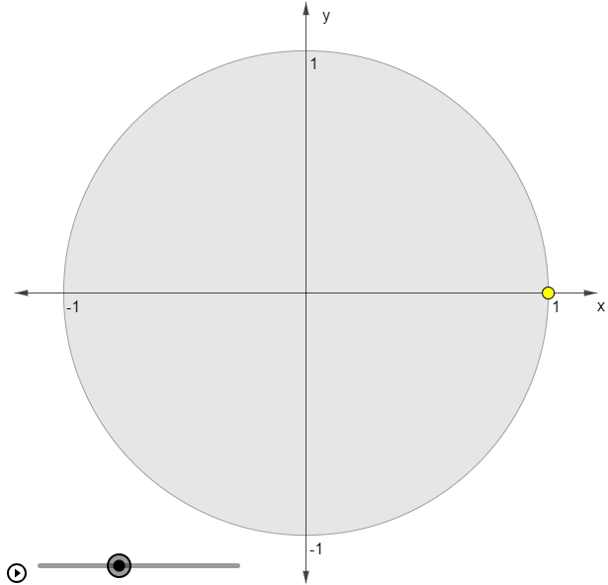
Estimate the height of the dot above the horizontal axis after it has turned through 45∘.
Estimate the angle that the dot needs to turn in order to be exactly 0.5 units above the horizontal axis.
Show how you can use Pythagoras' Theorem to calculate the height of the dot above the horizontal axis after it has turned through 45∘.
Again, without resorting to Trigonometry, calculate the height of the dot above the horizontal axis after it has turned through 30∘ and 60∘?
Are there any other angles for which you can calculate the height of the dot above the horizontal axis?

