This is a game for two players.
The first player chooses a positive even number that is less than 50, and crosses it out on the grid.
The second player chooses a number to cross out. The number must be a factor or multiple of the first number.
Players continue to take it in turns to cross out numbers, at each stage choosing a number that is a factor or multiple of the number just crossed out by the other player. (Use pencil so you can reuse the grid)

The first person who is unable to cross out a number loses.

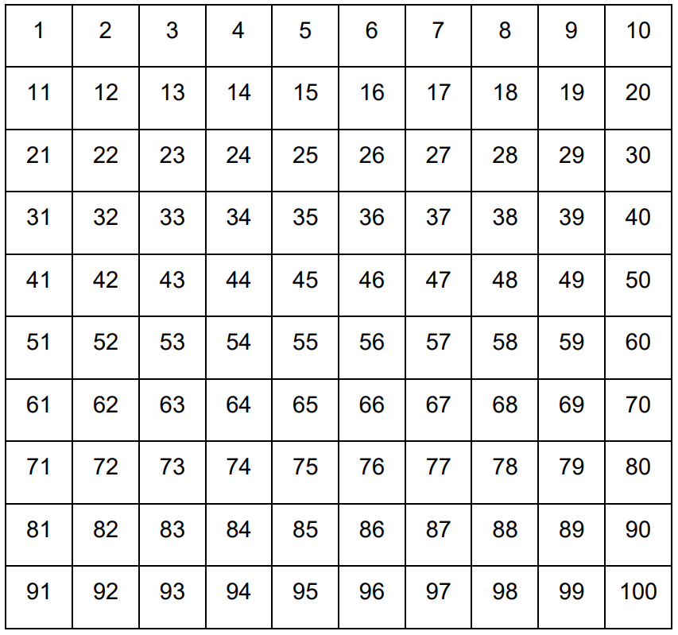

Do you have any winning strategies?

