Here is a 100 grid with some numbers shaded:
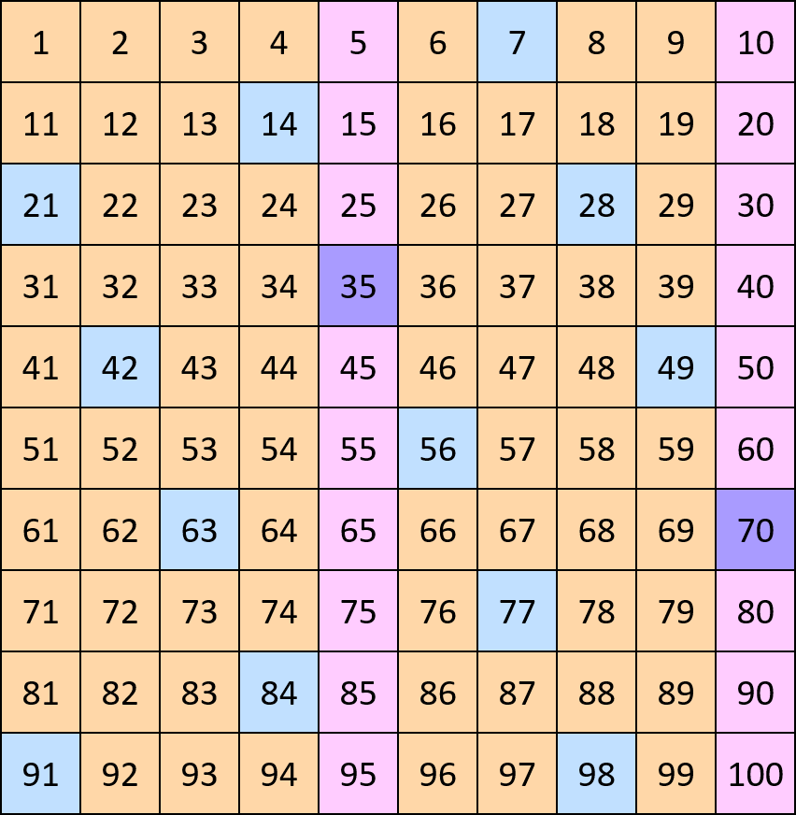
What do all the numbers shaded blue have in common?
What do you notice about all the numbers shaded pink?
Can you work out why two of the numbers are shaded in a purple colour?
Now, here is part of a 100 square shaded in a different way:
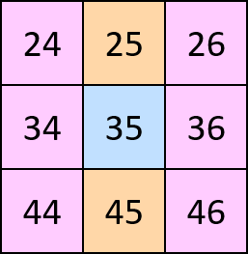
Can you explain the shading this time?
Here are some more parts of the 100 square, each one shaded according to different rules. Can you work out what the rules are for each?
Is there only one solution each time?
