What makes a shape a trapezium?

The diagonals of a trapezium divide it into four parts.
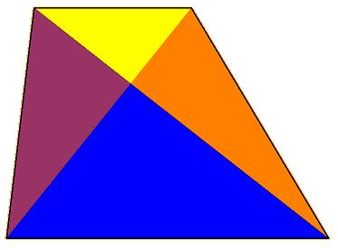
- Can you create a trapezium where two of those parts are equal in area?
- Can you create a trapezium where three of those parts are equal in area?
- Can you create a trapezium where all four parts are equal in area?
In each case can you explain how much freedom you have?
Or, if any of those challenges are impossible, say why you think that.

