Regular tessellations use identical regular polygons to fill the plane. The polygons must line up vertex to vertex, edge to edge, leaving no gaps.

Can you convince yourself that there are only three regular tessellations?

Semi regular tessellations (or Archimedean tessellations) have two properties:
- They are formed by two or more types of regular polygon, each with the same side length
- Each vertex has the same pattern of polygons around it.
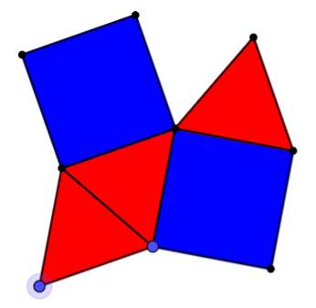
The picture shows an arrangement of equilateral triangles and squares. It looks like there's room for another triangle to fill the gap at the top... but can you prove it will fit?

If we tiled the plane with this pattern, we can represent the tiling as {3, 4, 3, 3, 4}, because round every point, the pattern "triangle, square, triangle, triangle, square" is followed. What would the pattern look like if you changed this order?

Can you find all the semi-regular tessellations?

Can you show that you have found them all?

