Each polygon "rolls" along a horizontal surface. Imagine the path traced by its dot.
Match each polygon to the horizontal distance-time graph and height-time graph of its dot.
 | 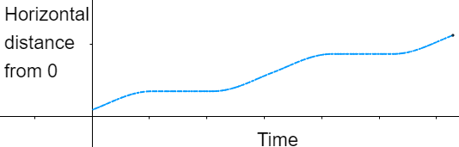 | 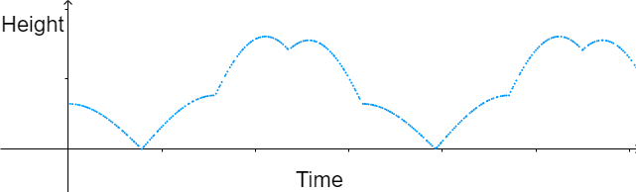
 | 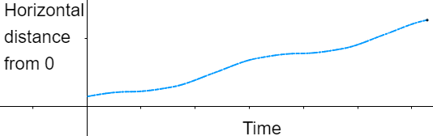 | 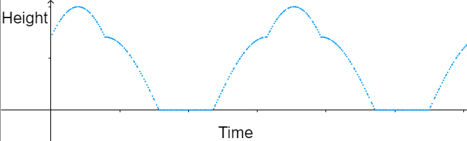
 | 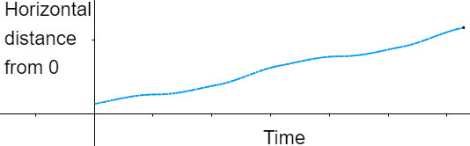 | 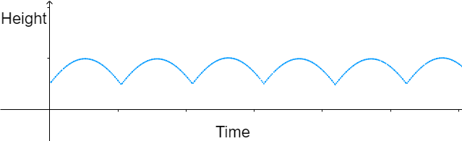
 | 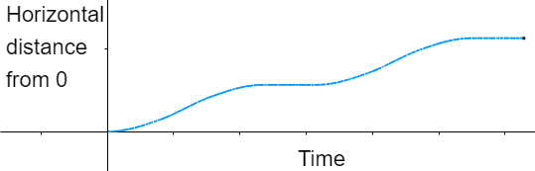 | 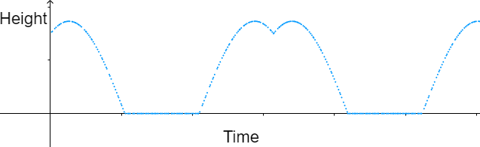
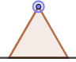 | 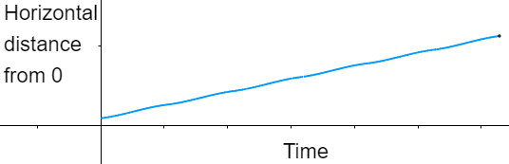 | 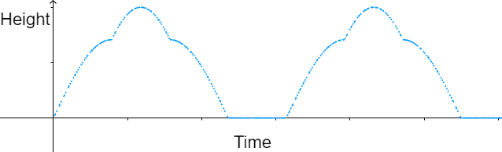
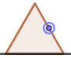 | 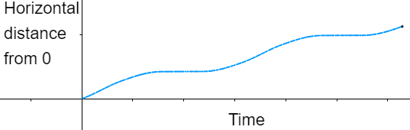 | 