Imagine the polygon "rolling" along a horizontal surface.
Match each polygon to the path traced by its dot, and to the distance-time graph of the dot’s journey.
 | 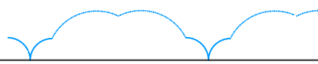 | 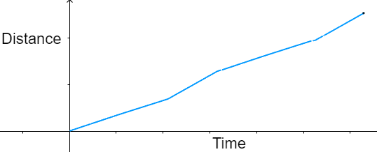
 | 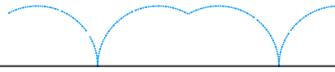 | 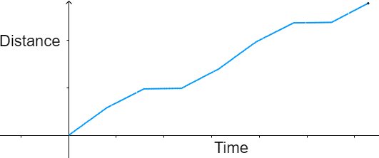
 | 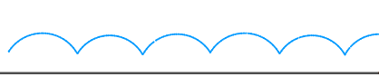 | 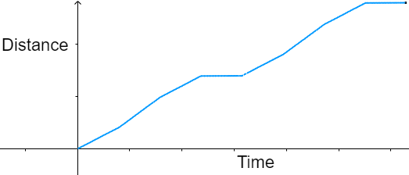
 | 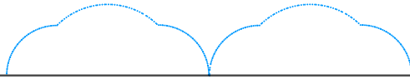 | 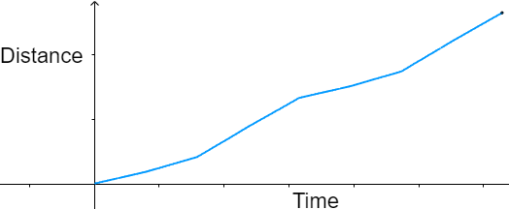
 | 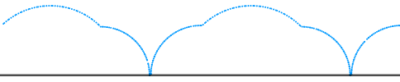 | 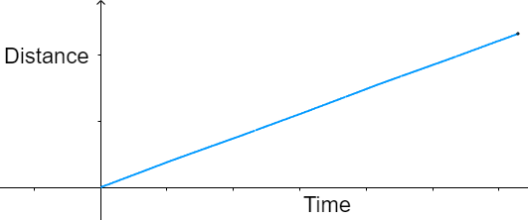
 | 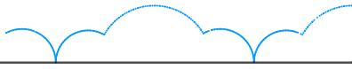 | 