This is a picture of the interactive number balance on the NRICH website:
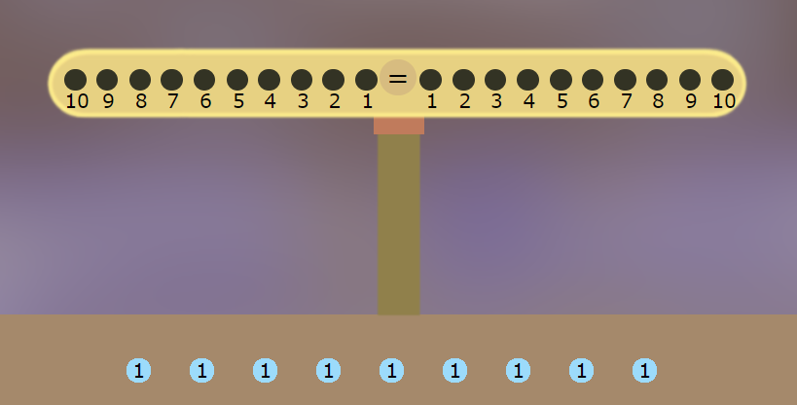
There are blue weights on the table, which you can hang onto the numbers.
Have a play with it!

Here is a picture of the number balance with some weights on it:

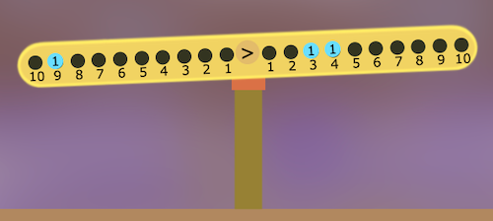

Where would you need to hang a weight to make it balance?

What about this picture below? Where would you hang a weight to make it balance?

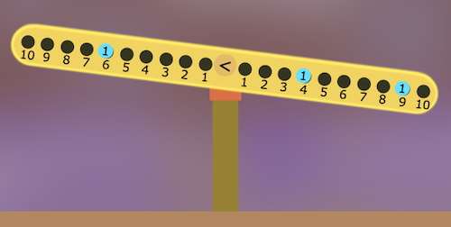

If you had to use two weights and make the picture below balance, where could you put them?

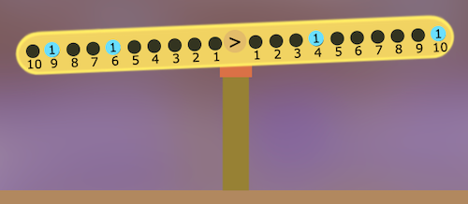

How many different ways can you make it balance with two weights?

