Draw a right-angled triangle ABC mark a point one third of the way along AB, one third of the way along BC and one third of the way along CA.
Join your three points together to form a new triangle. Here are some examples.
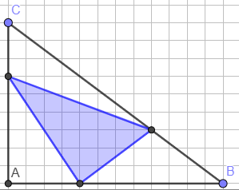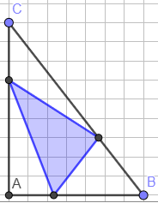

Can you work out the fraction of the original triangle that is covered by the new triangle?

Try a few more examples. What do you notice?
Can you explain why?

We started with a right-angled triangle... what about other triangles?

What fraction of this triangle is shaded?
Can you prove it?