A container holds 3 red balls, 2 blue balls and 1 yellow ball.
The balls are identical in all ways except colour.
The balls move around when the container is shaken, but they always settle in a triangle-shape in the middle.

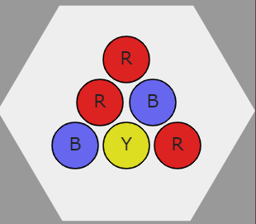
You win if at least one of the red balls is in a corner.
Approximately how often do you think you would win if you shook the container 100 times?
You could check your prediction by using the interactivity at http://nrich.maths.org/4313 .

Can you find a way of working out the theoretical probability of winning?

