A container holds 4 yellow marbles, 2 blue marbles and 1 red marble.
The marbles are identical in all ways except colour.
The marbles move around when the container is shaken, but they always settle in a hexagon-shape in the middle.

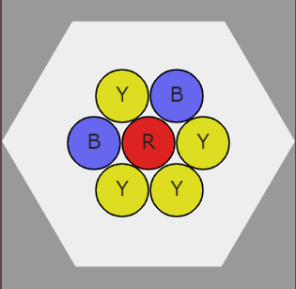
You win if two blue marbles touch.
Approximately how often do you think you would win if you shook the container 100 times?
You could check your prediction by using the interactivity at http://nrich.maths.org/4311 .

Can you find a way of working out the theoretical probability of winning?

