Here is a set of numbered balls used for a game:
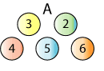

To play the game, the balls are mixed up and two balls are randomly picked out together.
For example:

The numbers on the balls are added together: 4 + 5 = 9

If the total is even, you win. If the total is odd, you lose.

How can you decide whether the game is fair?

Here are three more sets of balls:

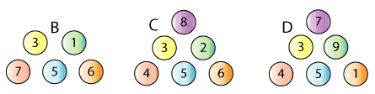

Which set would you choose to play with, to maximise your chances of winning?

What proportion of them do you expect to win each game?

