Guide to editing the NRICH site – Summer 2018

Logging in
To edit the NRICH website, you will need a login and password, which any member of the team can set up for you. Then visit https://nrich.maths.org/admin to log in. (You don’t need to change the tick boxes – accept cookies, but you don’t need development mode.)

Once you have logged in, you will see a screen like this:
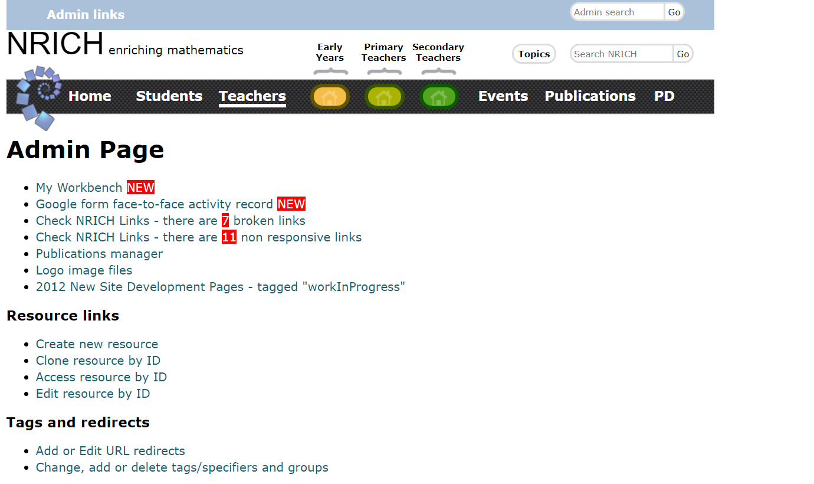

Editing a resource
Let’s get started with editing a resource! Go to your target resource (for practising, you could create a blank resource, or go to an unpublished resource such as https://nrich.maths.org/8660.)
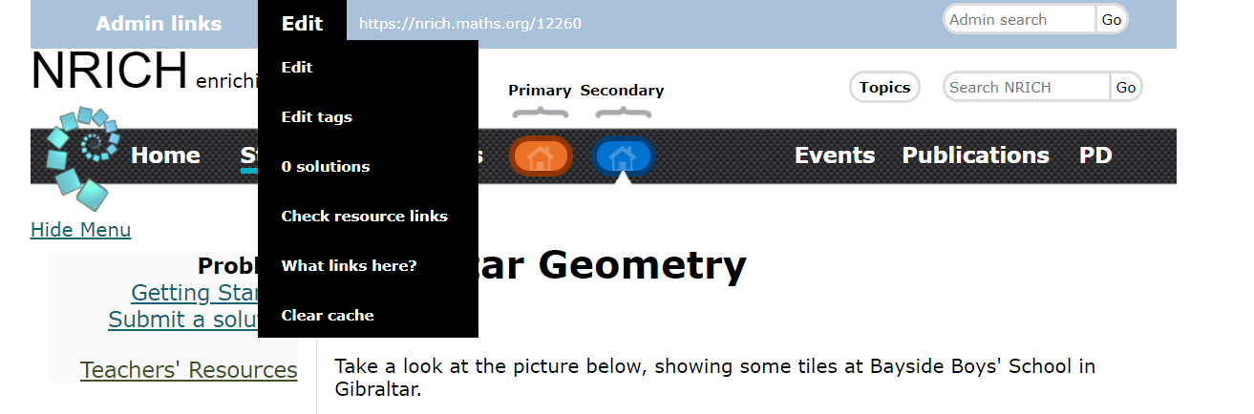
At the top of every resource, logged-in admin users can see the admin links bar, which includes the Edit menu shown above. Let’s go ahead and choose the first item in the menu: “Edit”. (We will come to “Edit tags” later in this document.)

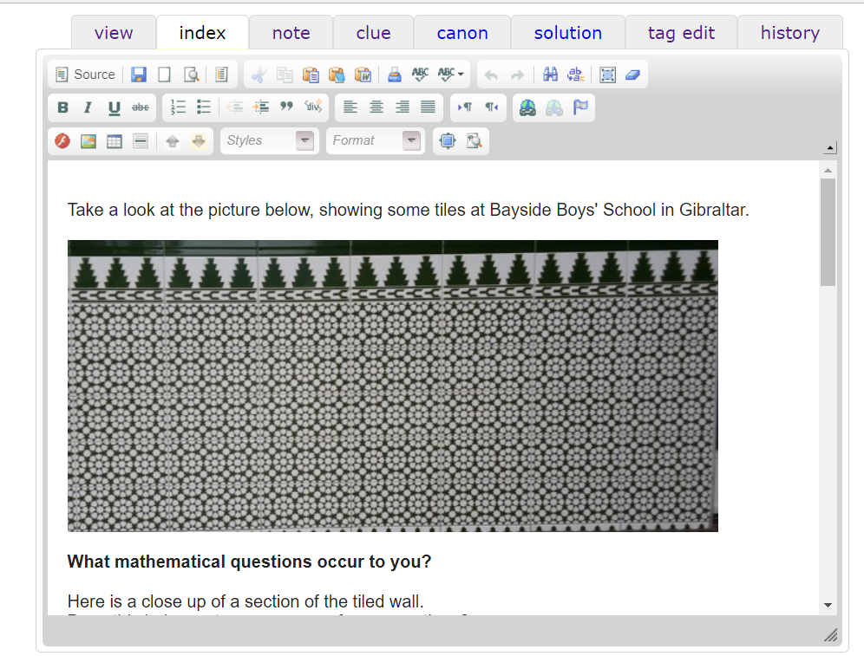
Clicking on “Edit” takes you to the WYSIWYG (what you see is what you get) editor shown in the screenshot above. Let’s go through each part of the editor view.

Choose which part of the resource to edit
The top tabs help you to navigate to the different parts of the resource:
view – takes you out of the edit menu to view the part of the resource you are currently editing
index – the main resource page which you get to when you go to the resource url (e.g. nrich.maths.org/8660)
note – the teachers’ resources page for the resource, with url e.g. nrich.maths.org/8660/note
clue – the Getting Started page for the resource, with url e.g. nrich.maths.org/8660/clue
canon – the Canonical Solution page. This is purely an admin page and is never seen by users. Its primary purpose is for the author of the problem to put notes about the intended solution before publication, to assist with writing up submitted solutions later on, but it can also be used to store useful links or notes. url is e.g. nrich.maths.org/8660/canon
solution – this is the solution page for the resource, where user-submitted solutions are written up by the team. url – nrich.maths.org/8660/solution
The last two tabs are a little different:
tag edit – takes you to the Tag Editor, which we will come to later
history – allows you access to previous versions of the resource.

Changing and adding text
Once you have navigated to the part of the resource you wish to edit, you can type text into the editor to change or add content. The three rows at the top of the editor are useful for formatting and editing what appears on the page.
Let’s take a closer look at the three rows below the tabs: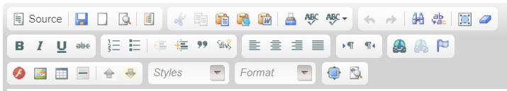
The important icons on the top row are the first two. “Source” allows you to switch between the WYSIWYG editor and the source code for the page. If something isn’t appearing correctly, looking at the source code tells you exactly what the HTML says and can allow you to tweak things. Next to that is the Save icon – if you try to navigate away without saving, you do get a pop-up to remind you, but it’s good practice to save regularly anyway. Most of the rest of the top row is irrelevant, although find/replace can be quite useful.
The second row is mainly about formatting, and uses standard icons. Note the link/unlink buttons in the right hand section.

Adding images and documents to the page
The first section on the third row has “insert Flash” (which we should not be using now as Flash is deprecated), “insert image”, “insert table”, “insert horizontal line”, and then the two very useful upload/insert arrows. The up arrow allows you to upload a file from your computer to the website so you can insert it into a resource. If it is an image file, you should fill in the “Origin” and “Link to original” before uploading, but this is not necessary for other file types.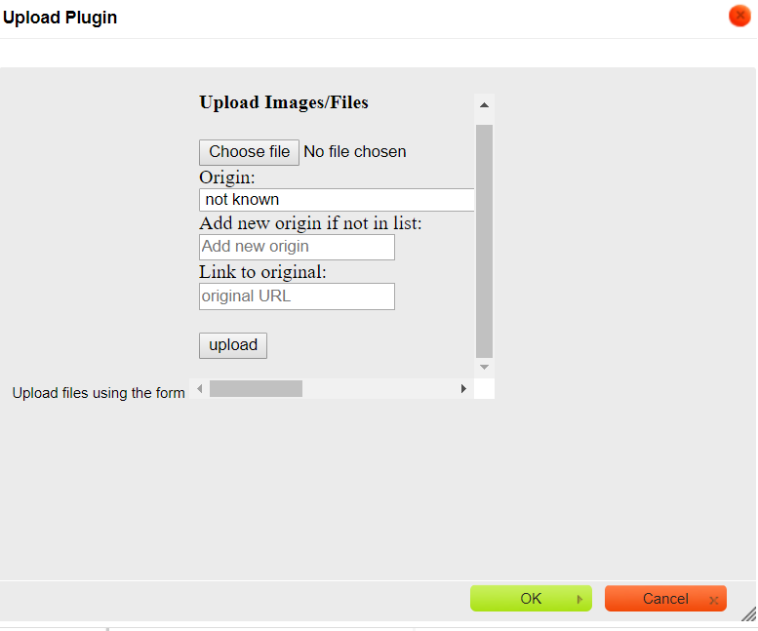
You need to click the grey “upload” button for each file that you are uploading, and then finally click “OK” once you have uploaded everything.
To insert a link to a file or image, put the cursor where you want it to go, and click the down arrow. Then choose your file or image from the list.

At the bottom of the page there are a few more things worthy of mention:
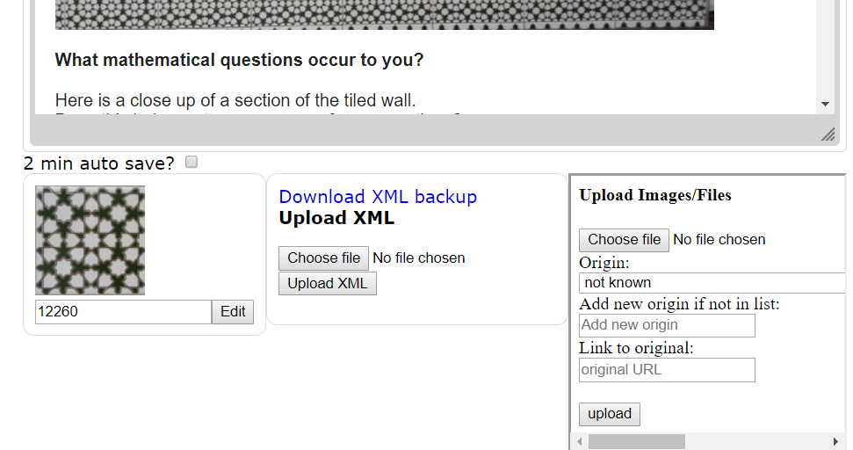

On the left, you can see the icon associated with the resource. All icons have filename icon.jpg, icon.png or icon.gif, and are 100 by 100 pixels in size. To associate the icon with the resource, all you have to do is upload it through the file upload system, and it will automatically appear in the bottom left. To replace an icon, upload the new version and it will overwrite the old one.
In the middle, you have the option to download the backup of the page. This can be useful for editing the source code. Once you have downloaded and edited the backup, you have the option to upload the file back.
On the right, there is another copy of the image/file uploader which does exactly the same as the up arrow discussed above.

Editing metadata using the Tag Editor
Now let’s go back to the Tag Editor.
This is what you see when you click “tag edit”, or when you create a new resource for the first time and set up the initial metadata.
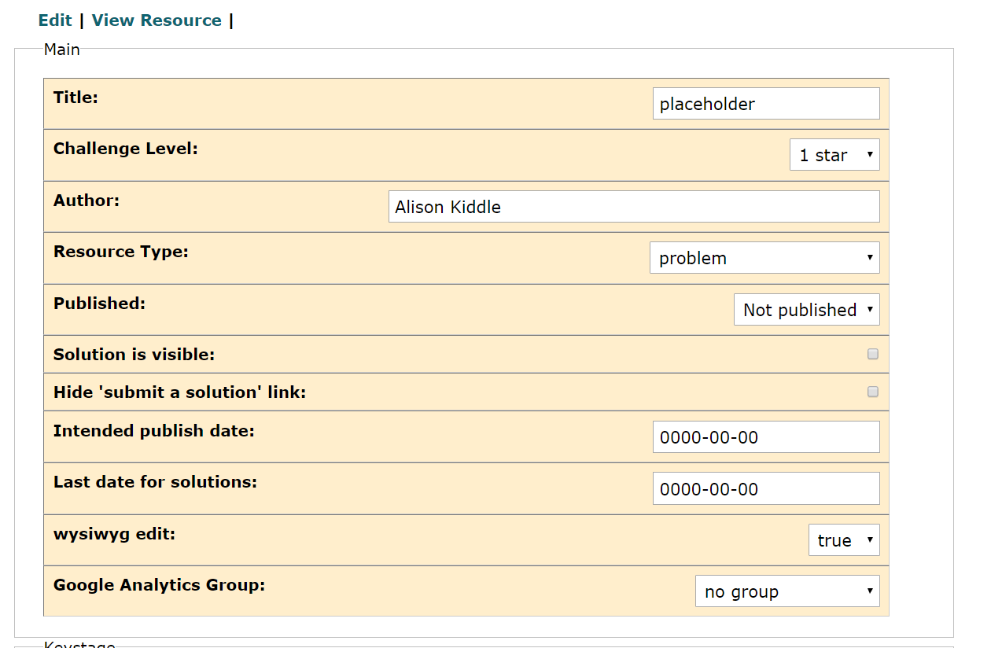
Resource type is usually Problem or Article or General. Lists and list editing is a little different, we will come to that later. Here you can unpublish or publish a resource; new resources by default are unpublished. Google Analytics Group should be set to no group initially; this should only be changed if tracking is required for a project.
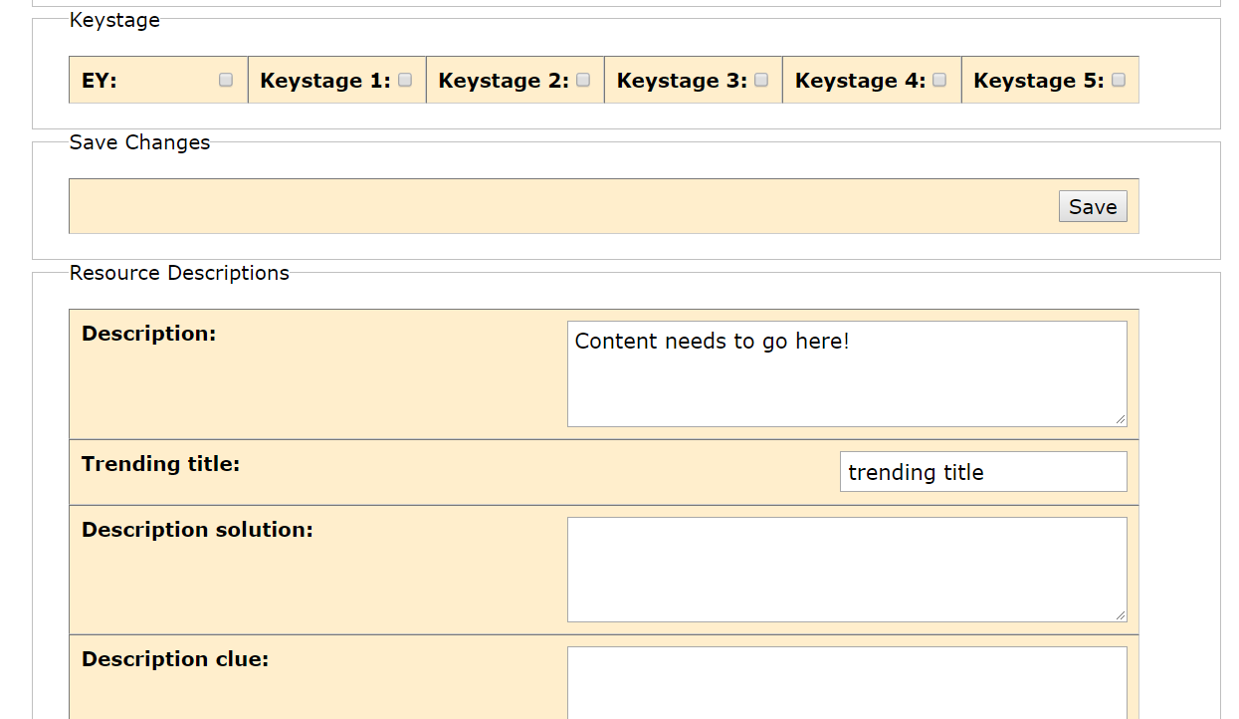
Content can have a key stage, and a variety of descriptions – everything should have a main description but trending, solution, clue and note descriptions are not required for all resources.
Notice the “Save” button – it’s exactly the same as the one at the bottom of the page, and is useful so that you can save without scrolling all the way down if you’ve only made changes at the top.

There are some ticky boxes which are fairly self-explanatory. Short Challenge should be ticked for all Short Problems. Notice there’s another Save button!
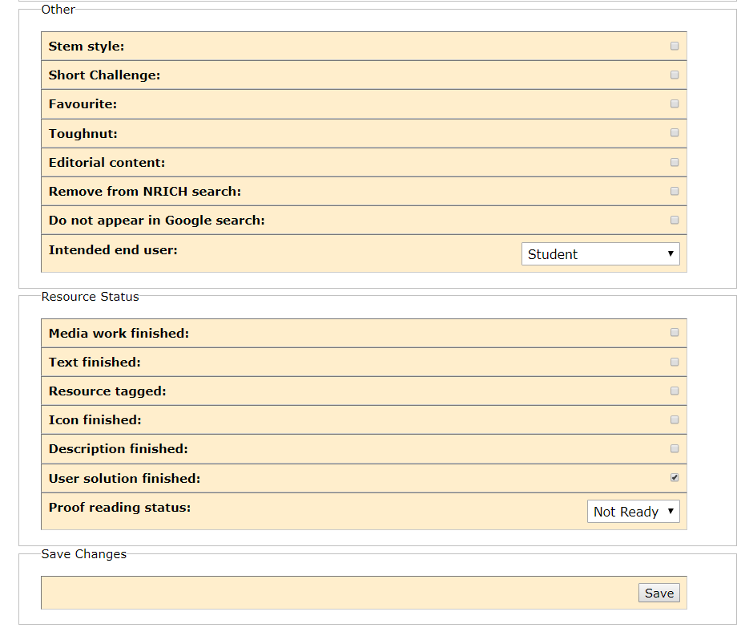

Adding tags for the tag cloud and for admin
Finally at the very bottom of the tag page you can add tags to the resource. This does not require pressing the save button; you just select a topic from the Broad Topic menu, choose the appropriate tag and click on it to add it to the orange bar. Then you can use the drop-down to set a weighting for it. Clicking on one of the grey tags removes it.
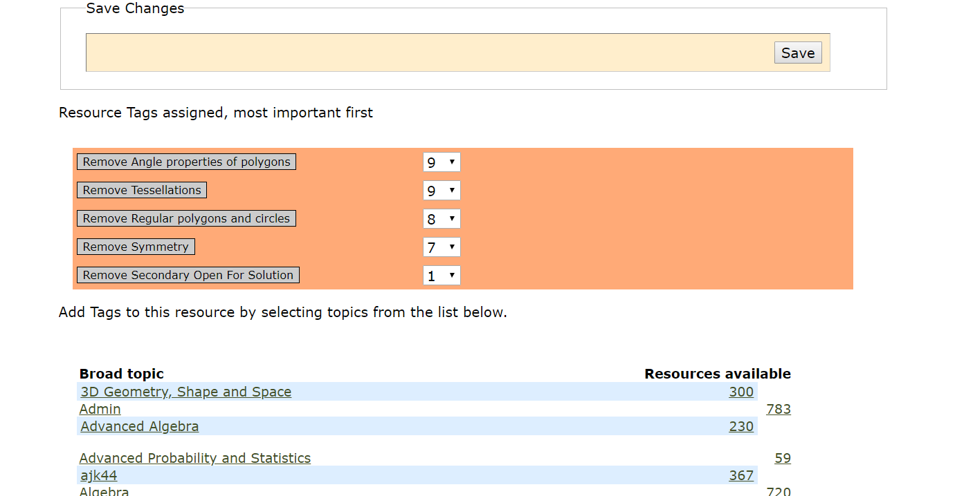
Tags are listed in alphabetical order. The following tag groups are admin only:
jdg18 STEM problem type Collections Secondary Mapping Document
Stage 5 Core Mapping Document sfh10 Site Structural Stage 5 Mechanics mapping document
ajk44 STEM mapping Secondary processes Stage 5 Statistics Mapping Document
jag55 Summer Students 2013 Secondary admin tags Developing Mathematical Creativity
Don Clare Core Maths NC Sec Mapping Dec 2017 Admin

List editing

Much of the site structure is controlled by lists which can be formatted in different styles.
Here is an example of a list:
https://nrich.maths.org/8703
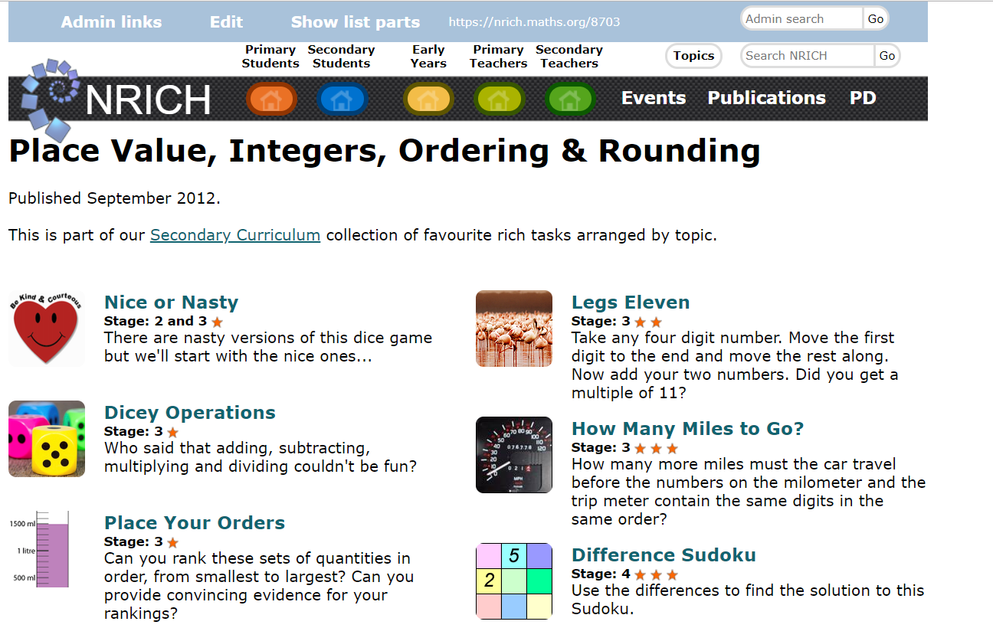
If you click “Show List Parts” you can see and edit the individual resources that make up the list, as well as seeing at a glance in the green sidebar whether all parts of the list are published:
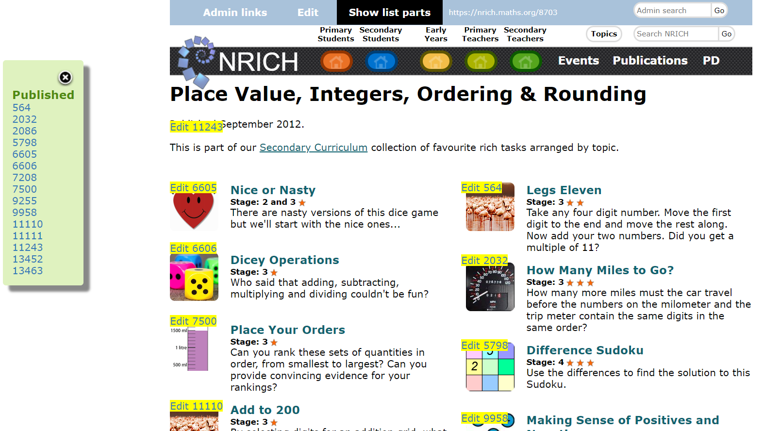

The list editor
Clicking on the Edit button next to “Show List Parts” at the top takes you to the List Editor:
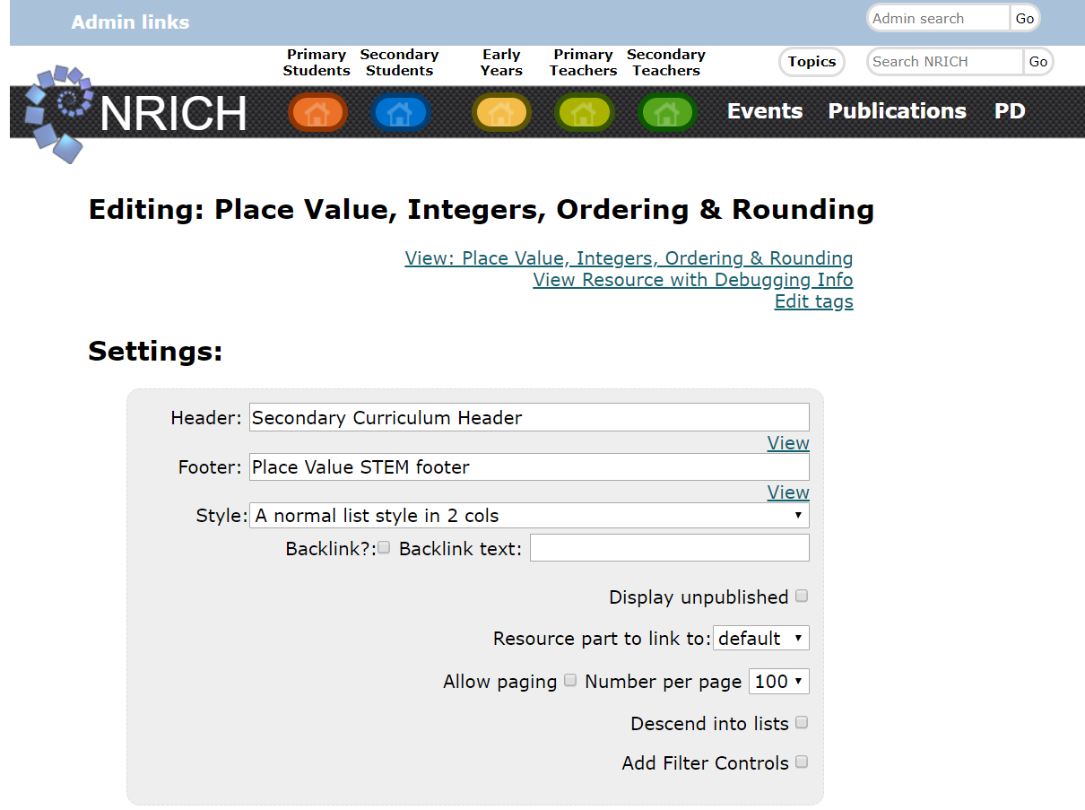
The Settings menu lets you choose whether your list has a header or footer (this one has both; you don’t have to have either). To add a header or footer, you will need to create a resource with type EmbedItem, and then type the name of your resource into the Header or Footer box. This resource has an EmbedItem called Secondary Curriculum Header, and one called Place Value STEM footer.
Next, you can choose a list style. There are lots of different styles for various purposes. This resources is a two column list. We don’t usually use the backlink feature at the moment.
It’s useful to tick “display unpublished” if you’re working on lists of currently unpublished content.
Resource part to link to: if you want a list that points straight to teachers notes or solutions for example, you can do that by changing this.
Allow paging is useful if you’re creating a list that will have lots of items; you can choose how many items per page.
Descend into lists: this is for when you create a list of lists, and you want each sub-list to be displayed in full rather than as a link. Filter controls is new and not widely used yet.

List Rules
A list can simply be a list of IDs; in which case, each rule will be the ID of the resource you wish to add. Our example list is generated by finding all resources with particular metadata. By adding clauses, you can make a set of conditions which must all be satisfied for a resource to appear in the list. By adding rules within a clause, as long as one of the rules in the clause is satisfied the resource will appear.
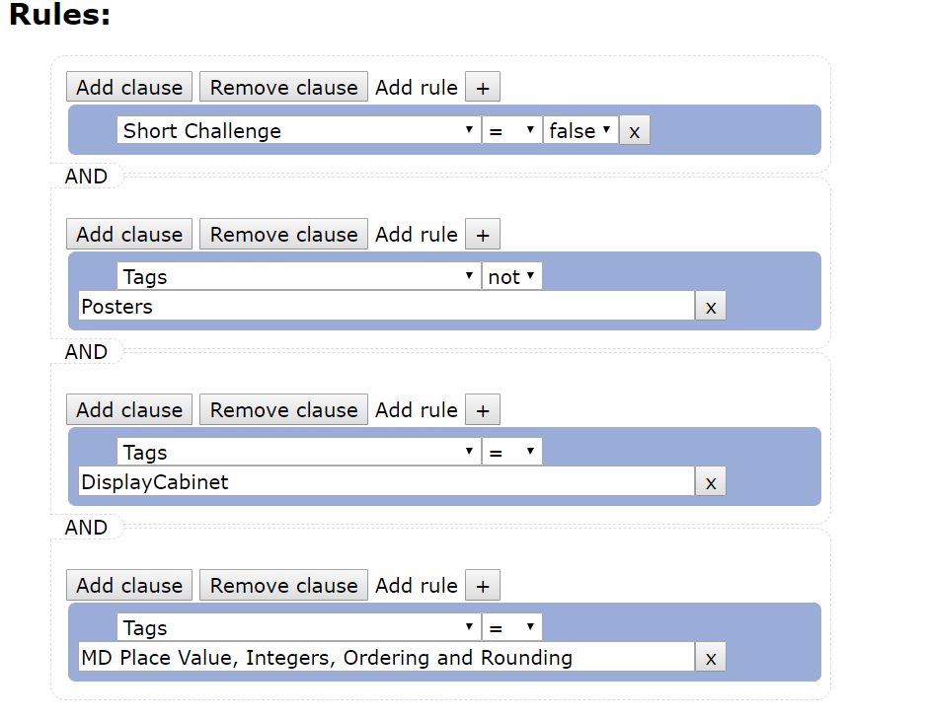

List Order, Preview and Save
You can specify a sort to order the list. This one is ordered by Key Stage and Difficulty, but there’s also a Custom sort; you can create a custom order for a list by viewing the list and dragging/dropping items in place. Then you can lock the list so it can’t be reordered. There is a preview button and a save button to save your changes.
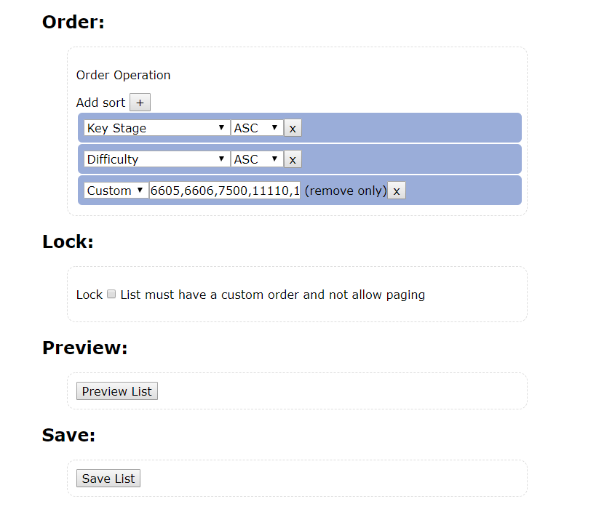
At the very bottom of the list editor page there are the XML Download options and the Image Upload options. A List should have an icon unless it is not visible in the site search. By choosing “Edit tags” at the top of the list editor, you can also add a description, check whether the list is visible in the search, and change whether the target audience is Students or Teachers.

