To Play:

You will need a set of Quadrilaterals Game Cards

Shuffle the cards well.

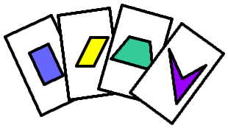

Now deal 8 to each player (face down), and place the rest in a pile in the middle of the table, again all face down. Turn over the top card of the stack onto the table (face up): this forms the discard pile.

You can look at your own cards, but not those of anyone else.

Your aim is to make two 'tricks', where each trick has to consist of a picture of a shape, a name that describes that shape, and two properties of the shape. For example, you might have a picture of a kite, the word 'kite', and then two properties of a kite. But you could also have a picture of a kite, the word 'quadrilateral', and then two properties of a kite.

Each player goes in turn. On each go, a player can either take the top card from the discard pile, or the top card from the stack (which will be face down). Then the player can decide which of the 9 cards s/he will discard, and s/he puts it on the top of the discard pile (face up). Then the next player has a go.

The game finishes when someone has two tricks (but don't forget that you'll need to check that the person has got it right!).

Enjoy the game.

