trapezium | trapezium
rhombus | rhombus
quadrilateral | quadrilateral
kite | kite
rectangle | rectangle
parallelogram | parallelogram
square | square
3 angles are 90º | all angles equal
all sides equal | has rotational symmetry
2 pairs of parallel sides | all angles 90º
diagonals cut at right angles | 2 pairs of adjacent sides equal
has no rotational symmetry | diagonals unequal in length
has rotational symmetry of order 2 | 1 pair of opposite angles equal
diagonals equal in length | diagonals bisect angles at the vertices
4 angles | has line symmetry of order 2
1 pair of parallel sides | has rotational symmetry of order 4
diagonals bisect each other | 4 sides
has line symmetry of order 4 | 2 pairs of opposite angles equal
2 angles are 90º | diagonals unequal in length
 | 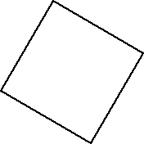
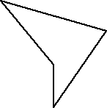 | 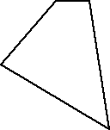
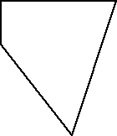 | 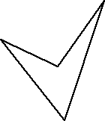
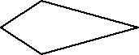 | 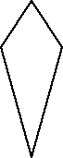
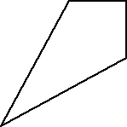 | 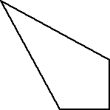
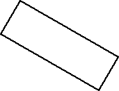 | 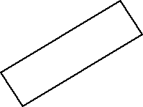
 | 
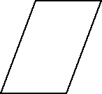 | 
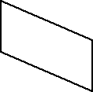 | 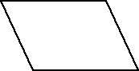
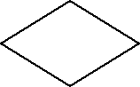 | 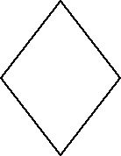
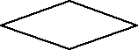 | 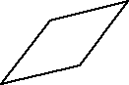
 | 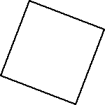
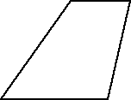 | 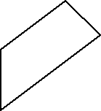
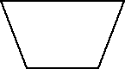 | 