This activity uses the same ideas as the problem ‘Ring a Ring of Numbers’.
This time, we are changing the ring so that there are only three squares.
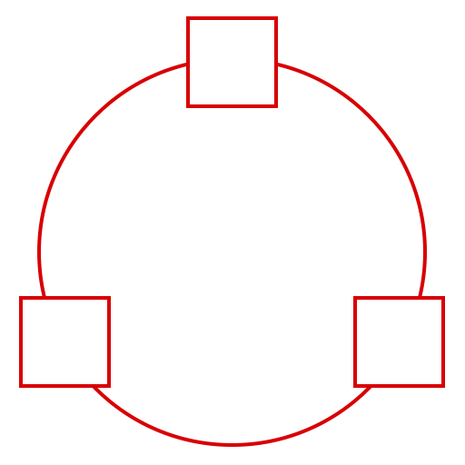
Can you place three different numbers in them so that the difference between each pair of joined squares is odd?
Can you make the differences even?
What do you notice about the sum of each pair in each case?
Try with different numbers of squares around the ring.
What happens with 5 squares? 6 squares?
What do you notice?

