Here is a picture of four numbers placed in squares on a circle so that each number is joined to two others:
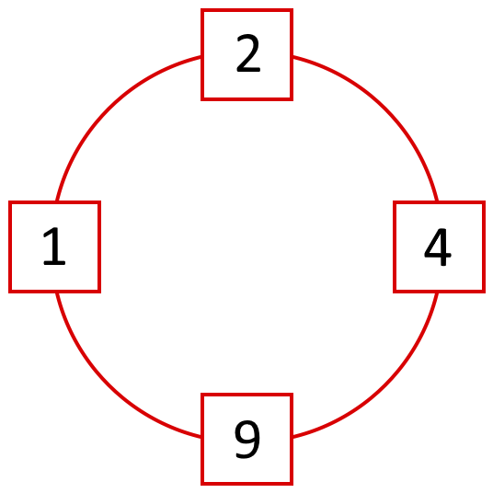
What do you see?
What do you notice?
Choose four numbers out of 1, 2, 3, 4, 5, 6, 7, 8 and 9 to put in the squares so that the difference between joined squares is odd.
Only one number is allowed in each square. You must use four different numbers.
What can you say about the sum of each pair of joined squares?
What must you do to make the difference even?
What do you notice about the sum of the pairs now?

