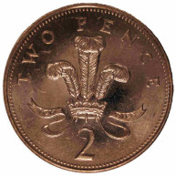  ¾ of 4p | 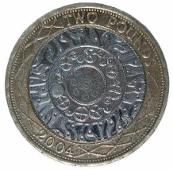  ¹/₁₀₀ of £4 | 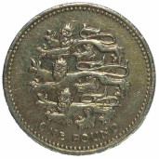  ³/₁₀ of £1
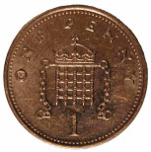  3p | 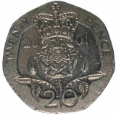  40p | 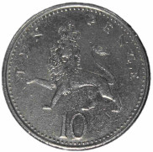  30p
¼ of 40p | 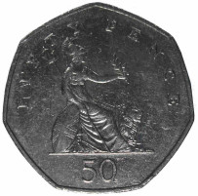  ½ of 50p | ¼ of £4
10p | 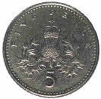  25p | £1
¾ of £2 | ¼ of 20p | ³/₁₀ of 20p
£1.50 | 5p | 6p
½ of £1 | ¹/₁₀ of 20p | ⁷/₁₀ of £1
50p | 2p | 70p

  http://nrich.maths.org | http://nrich.maths.org | http://nrich.maths.org
http://nrich.maths.org | http://nrich.maths.org | http://nrich.maths.org
http://nrich.maths.org | http://nrich.maths.org | http://nrich.maths.org
http://nrich.maths.org | http://nrich.maths.org | http://nrich.maths.org
http://nrich.maths.org | http://nrich.maths.org | http://nrich.maths.org
http://nrich.maths.org | http://nrich.maths.org | http://nrich.maths.org
http://nrich.maths.org | http://nrich.maths.org | http://nrich.maths.org
http://nrich.maths.org | http://nrich.maths.org | http://nrich.maths.org

