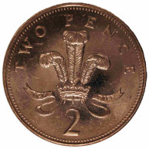  Half of 2p | 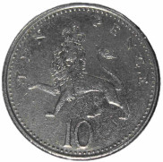  Half of 10p | 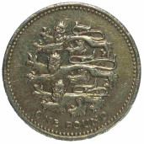  Half of £1
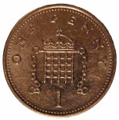  1p | 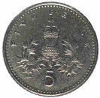  5p | 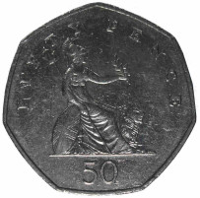  50p
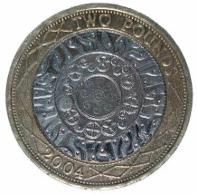  Half of £2 | 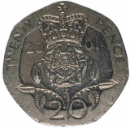  Half of 20p | Half of 50p
£1 | 10p | 25p
Tenth of £2 | Quarter of £1.20 | Fifth of 15p
20p | 30p | 3p
Third of £2.10 | Hundredth of £2 | Fifth of £3.50
60p | 2p | 70p

  http://nrich.maths.org | http://nrich.maths.org | http://nrich.maths.org
http://nrich.maths.org | http://nrich.maths.org | http://nrich.maths.org
http://nrich.maths.org | http://nrich.maths.org | http://nrich.maths.org
http://nrich.maths.org | http://nrich.maths.org | http://nrich.maths.org
http://nrich.maths.org | http://nrich.maths.org | http://nrich.maths.org
http://nrich.maths.org | http://nrich.maths.org | http://nrich.maths.org
http://nrich.maths.org | http://nrich.maths.org | http://nrich.maths.org
http://nrich.maths.org | http://nrich.maths.org | http://nrich.maths.org

