Sixteen children are standing in four rows of four, one behind the other. They are each holding a card with a number on it. In each column, all four children are wearing clothes of the same colour.
Red | Blue | Yellow | Green
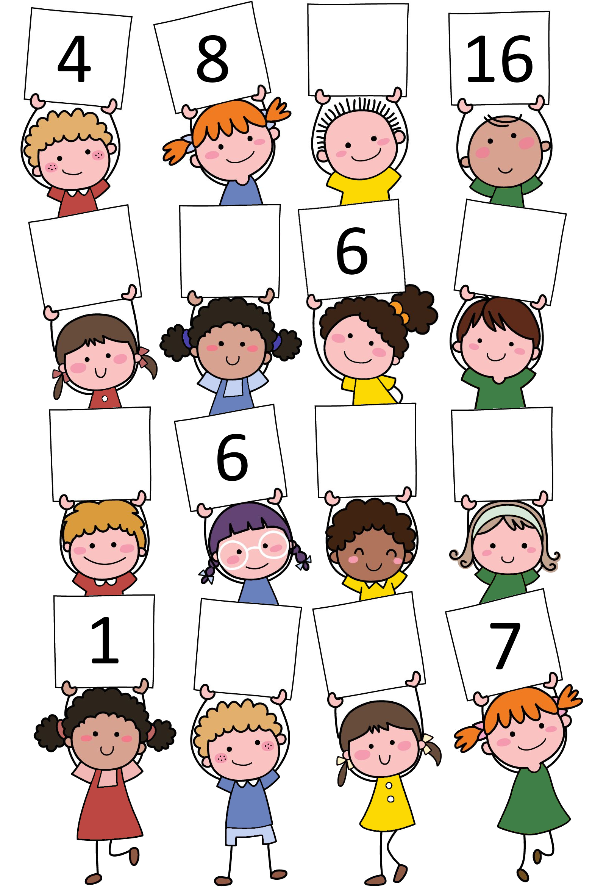
Each child in blue is holding a number which is four more than the child next to them who is wearing red.
The children in yellow each have a number which is double the number of the child in the same row wearing red.
Some of the numbers that the children in red, blue and yellow are holding are missing. What should these numbers be?
How have the numbers of the children in green been worked out? What are the two missing numbers?
If there was another row of four children standing at the back, behind the fourth row, what numbers would they be holding?

