You might like to use some Cuisenaire rods or the interactivity on the NRICH website to explore the ideas in this task.
We are going to look at some rods that are different colours and different lengths.
We can arrange white and red rods in many different ways to be the same length as a yellow rod. Here are some of them:
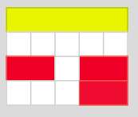
Can you find all the ways of using red and white rods that are equivalent to a yellow rod?
How will you know that you haven't missed any out?

The dark green rod is longer than the yellow rod.


Can you find all the ways of using red and white rods that are equivalent to a dark green rod?
How will you know that you have found them all?

