Three cubes are glued together to make a cuboid of dimensions 3 by
1 by 1.

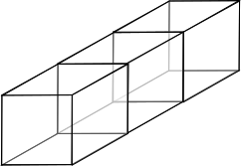

Label four points on the cuboid with coordinates
$$A=\left(0,0,0\right) B=\left(1,1,1\right) C=\left(2,1,0\right) D=(3,1,0)$$

Now the challenge is to find at least two different ways to calculate the angles ∠ABC and ∠ABD.

