An arithmagon is a polygon with numbers at its vertices which determine the numbers written on its edges. The number on each edge is the sum of the numbers at its vertices.

Fill in the missing numbers in these arithmagons.

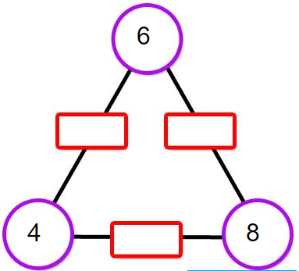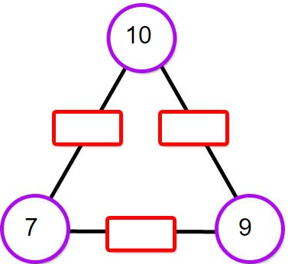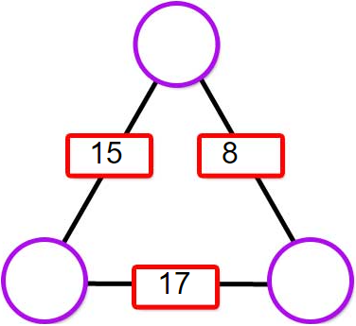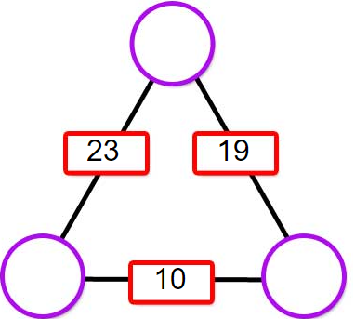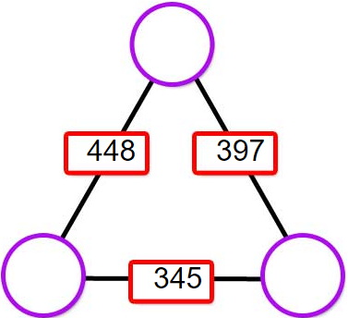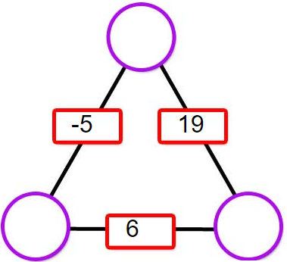

You could also make up some of your own for a partner to solve.

Once you are confident that you can work out the values at the vertices efficiently, here are some questions you might like to consider:
- Can you describe a strategy to work out the values at the vertices irrespective of the values given for the edges?
- By looking at the numbers on the edges, how can you predict whether the numbers at the vertices will all be positive?
- By looking at the numbers on the edges, how can you predict whether the numbers at the vertices will all be whole numbers?
- What happens to the numbers at the vertices if you increase one or more of the numbers on the edges by 1? By 2? ... By n?
- What relationships can you find in square arithmagons? Or pentagonal arithmagons?

