
Here are 8 dots in a circle.
Choose a dot to start from and connect it to another dot. What was your step size? Continue round the circle, joining dots that are the same step size apart, until you get back to your starting point.
When a circle has 8 dots you can move around the circle in steps of length 1, 2, 3, 4, 5, 6 or 7.
If you move around the circle in steps of 2, you miss some points.

If you move around the circle in steps of 3, you visit all the points.
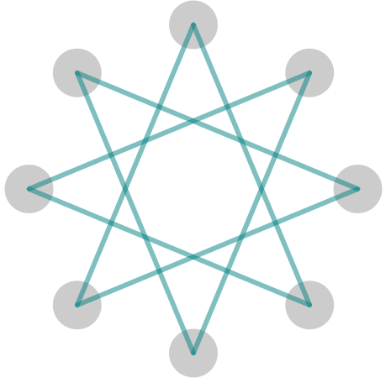
How else can you visit all the points?
When a circle has 9 dots there are 6 different step sizes where you visit every point. Which step sizes allow you to do this?
Now consider 10 points. Can you find the 4 different step sizes in which we can visit every point?
Explore what happens with different numbers of points and different step sizes.
How can you work out what step sizes will visit all the points for any given number of points?
Now consider 5 points. You can visit all the points irrespective of the step size. Which other numbers have this property?
Can you find a relationship between the number of dots on the circle and the number of steps that will ensure that all points are hit?

