Use a ruler and set square to practise drawng tlted squares. Once you start drawing a square, can you predict where the other corners will be?
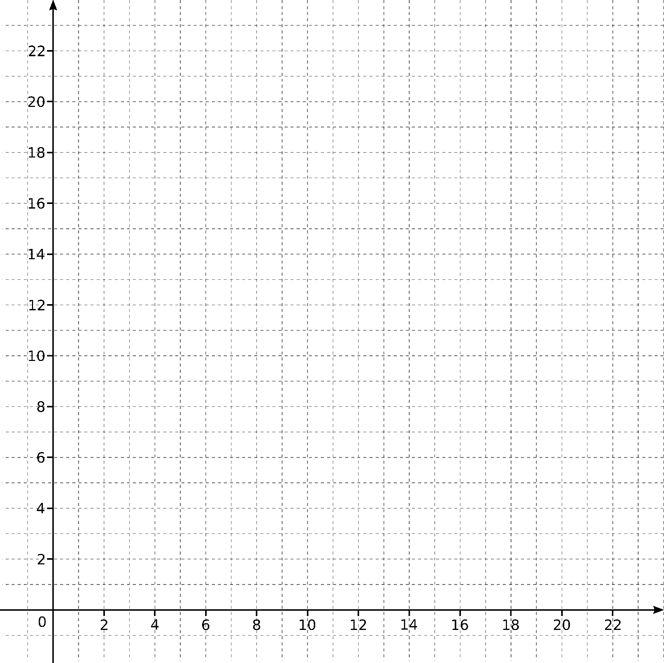
Describe how to construct a square when you are given two adjacent corners.
Describe how to construct a square when you are given two opposite corners.
Decide which of the collections of points below form a square.
Can you do this without plotting the points on a grid?
- (8,3), (7,8), (2,7), (3,2)
- (3,3), (7,4), (8,8), (4,7)
- (16,19), (18,22), (21,20), (19,17)
- (4,20), (21,19), (20,2), (3,3)

