Start with the numbers from 0 - 20.
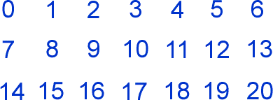

Can you arrange these numbers into seven sets of three numbers, so that the totals of the sets are consecutive?
For example, one set might be $\{2, 7, 16\}$
$$2+7+16=25$$
And another might be $\{4, 5, 17\}$
$$4+5+17=26$$
As 25 and 26 are consecutive numbers these sets are the kind of thing that you need.

Once you’ve found a solution, here are some questions you might like to consider:
- Is there more than one possible set of seven consecutive totals? How do you know?
- Is there more than one way to make the seven totals?
- Could you make seven sets that all had the same total?
- Could you make seven sets whose totals went up in twos? Or threes? Or…

