Class 3 were playing a game. There were ten cards with the digits 0 to 9 on them.
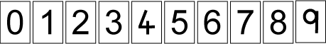

These cards were put into a bag and players took out four cards and made a number out of them. At first they made the highest number they could. Sinita took out

 | and made | 

Then they made the lowest number they could. Jamie took out
 | and made | 
"You can't put zero at the beginning of a number," objected Paul. The class discussed this and decided that Jamie had made four hundred and fifty-seven.
Next they played to make the highest even number. Jill took out

and Vincent took out

Who won? Why?
Then they played to make the highest odd number. Belinda took out
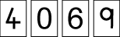

and Ali took out
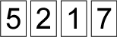
Who won? Why?
Next they played to make the lowest even number. Rohan took out

and Ben took out
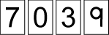
Who won? Why?
The last game they played was to make the closest number to 5000. Alice took out
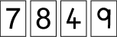
and Chloe took out

Who won? Why?
Play some of the different versions of this game with a friend. Which digits are the most helpful? Why?
Once you've played this game a few times, have a go at playing Nice or Nasty. This game is very similar except you draw and place the digits one at a time, so you'll need to think carefully about where to put each one!

