This is a game for two players.
The object of the game is to be first person to make a square.

Rules
Players take it in turns to choose a dot on the grid.
The winner is the first player to choose four dots that can be joined to form a square.
If you play online, player one is blue and player two is red.

Here is a picture showing a completed game won by blue:

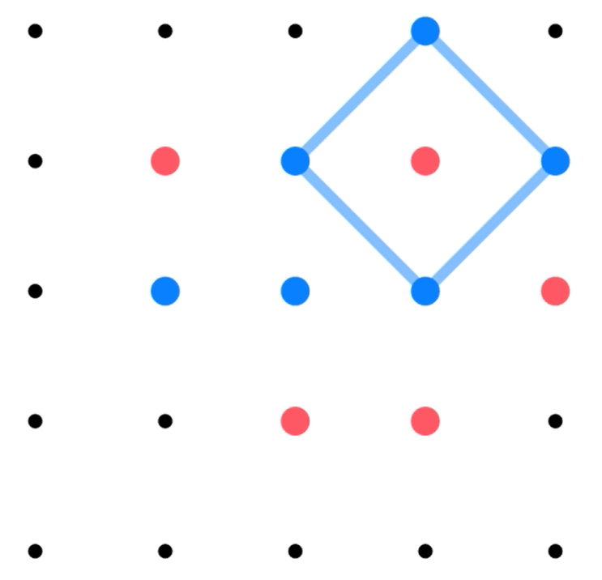

Squares can be any size, and can be tilted like the one in the picture.

Play the game a few times. You can play online, or with paper and pencil.

You could test your strategy by playing online against the computer.
Once you have a strategy, you could try playing on different sized grids.

