Four pupils from Class 4, Ben, Ali, Katie and Charlene, decided to make graphs of the sizes of the seven classes in the school.
Ben and Ali found out how many children there were in Classes 1, 2 and 3.
Katie and Charlene found about Classes 5, 6 and 7.
Of course they all knew the number of children in Class 4.
Ben and Ali drew a bar chart. It looked like this:
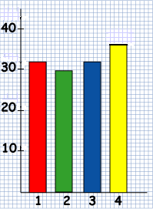

Katie and Charlene drew this pictogram:

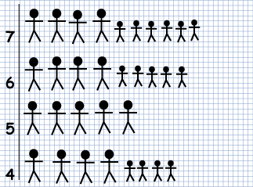

Kate and Charlene have forgotten to add a key to their pictogram. What should the key say?
How many children were there altogether in Classes 5, 6 and 7?

