A spider is sitting in the middle of one of the smallest walls in my living room and a fly is resting by the side of the window on the opposite wall, 1.5m above the ground and 0.5m from the adjacent wall.

What is the shortest distance the spider would have to crawl to catch the fly?

The room is 5m long, 4m wide and 2.5m high.

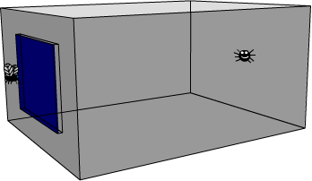

If the fly walks down the wall, is there a point at which the spider would be better changing its route?

