You have been imprisoned at the top of the Tall Tower by the Wicked Magician!
You can get out by climbing down the ladders. As you come down you collect useful spells.
You can go down the ladders and through the doorways into an adjoining room, but you cannot go into the same room twice, nor climb up the ladders.
The numbers in the rooms show how many spells there are in each one.
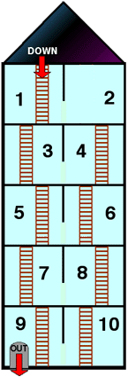
Which way should you go to collect the most spells?
And which way to collect as few as possible?
Can you find a route that collects exactly 35 spells?
Below you can read how some other children started this problem.
Krishan says:
I thought that if I want to get the highest number of spells I need to visit as many rooms as possible.

Hiromi says:
I wondered whether it was possible to visit all of the rooms in counting order.

Fay says:
I chose a route and then added up how many spells I had collected.

Did you start the problem in the same way as any of these children?
What do you think about each method?

