In these number pyramids, the number in the bottom left hand corner determines all the other numbers.
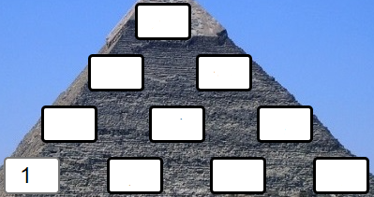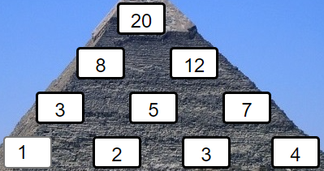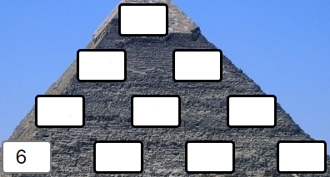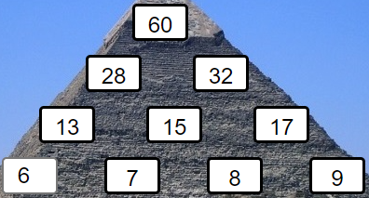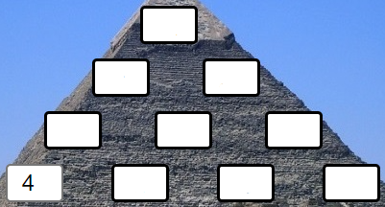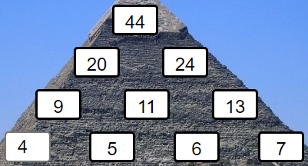
Try creating some more number pyramids which follow the same rules. What patterns do you notice?
Here are some questions to consider:
- If I give you the number in the bottom left hand corner, can you work out the top number without working out the middle layers?
- Can you explain why some numbers are impossible to get at the top, if you start with a whole number in the bottom left hand corner?
- If I give you the number at the top, can you find a quick way of working out the number in the bottom left hand corner?
Do your insights still apply if you use negative numbers or decimals?
Can you justify any generalisations that you have reached?
Perhaps you could use algebra to explain your thinking.
Can you adapt what you discovered about 4-layer pyramids to larger pyramids?
What if the numbers on the bottom layer go up in 2s? Or 3s?

