In a number pyramid, the numbers on the lower layers determine the numbers above them.
Start by choosing three single-digit numbers and placing them in the bottom row of the number pyramid. Here are some examples of number pyramids with different starting numbers.
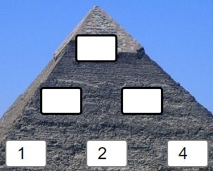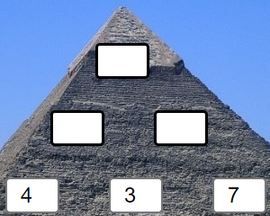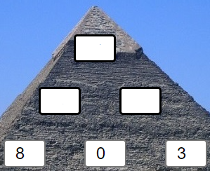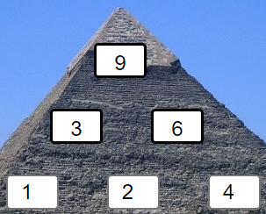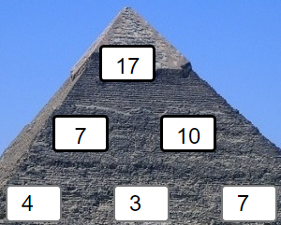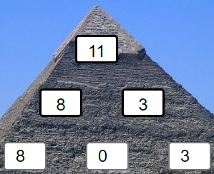
Can you work out how the numbers in the upper layers are generated?
Here are some questions to consider:
If I tell you the numbers on the bottom layer, can you work out the top number without working out the middle layer?
If you change the order of the numbers on the bottom layer, will the top number change?
Given any three numbers for the bottom, how can you work out the largest possible number that could go at the top?
If I give you a target for the top number, can you quickly find three possible numbers for the bottom?
Can you adapt what you discovered about 3-layer pyramids to larger pyramids?

