Charlie has been exploring rhombuses with vertices drawn on the points of a square dotty grid.
Charlie said "Whenever I join two points to make a line, I can use my line as a side of several different rhombuses".
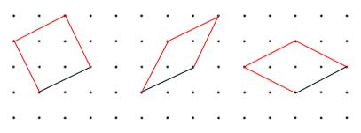

Do you agree with him?

When you are given a line, is there a quick way to work out how many rhombuses can be drawn using that line as one of the sides?

Alison said "When I draw a rhombus, it shares its diagonal with infinitely many other rhombuses."
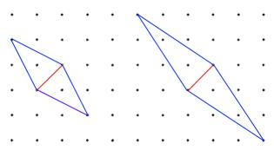

Do you agree with her?
Not all lines can be the diagonal of a rhombus. Is there a quick way to decide which lines could be the diagonal of a rhombus?

