This is a game for two players.
Players take it in turns to choose a dot on the grid. The winner is the first to have chosen four dots that can be joined to form a rhombus.
If you play online, the first player will place blue circles and the second player will place pink squares.
Here is a picture showing a completed game being won by the pink square player:
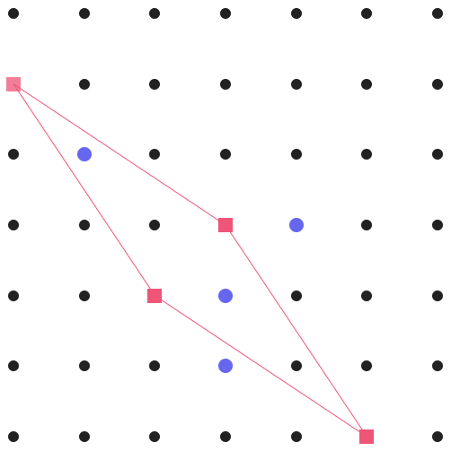
Rhombuses can be anywhere and any size.
Once you've played a few times against a friend, you might like to discuss your strategies, and then test them by playing against the computer.
Can you find a winning strategy?

