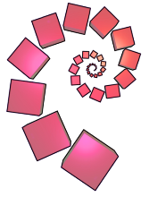
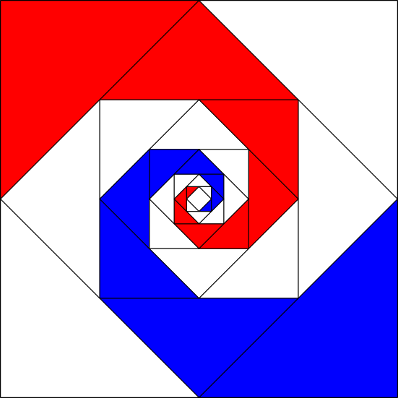
Look at the image on the right for a little while and then look away.

Can you recreate (draw) the image without looking at it?

Try describing the image to someone else.
What do you notice?
What mathematical questions would you like to ask?
nrich.maths.org
Baravelle

