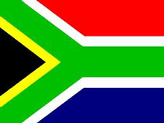
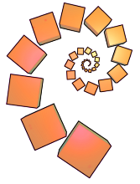
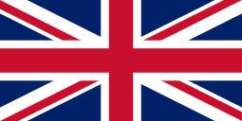
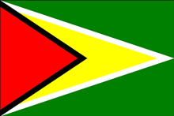
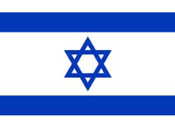
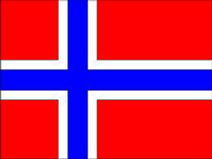
Can you find any pairs of parallel lines?
Are there any lines that are perpendicular to each other?
How do you know?

nrich.maths.org
What shapes can you see in the flag? Can you describe their angles?
Does the flag have any lines of symmetry? How many?

During the Olympics, lots of national flags are on display. Choose a flag and investigate:

National Flags

