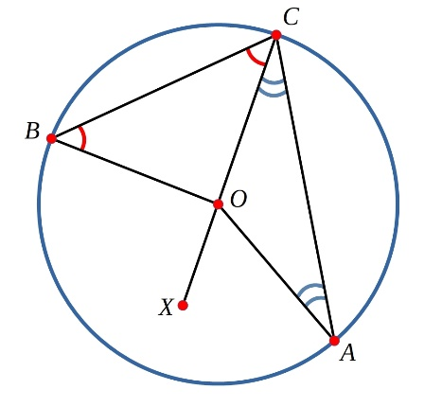
The angle at the centre of the circle was double the angle at the circumference.
Can you use this to prove these three corollaries (things which are also true)?
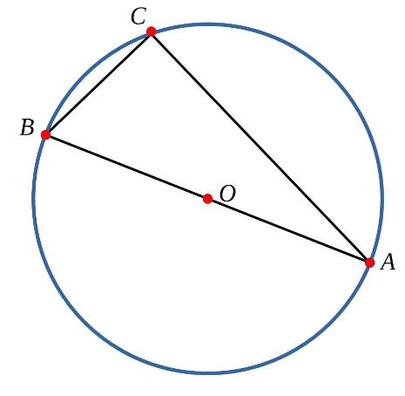
Corollary 1
Can you show that the angle in a semi-circle is a right-angle?
(i.e. if AB is a diameter then angle ACB=90º.)

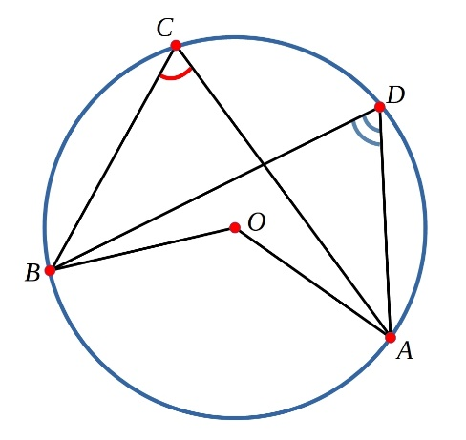
Corollary 2
Can you show that the two angles marked in the diagram are equal?

Corollary 3
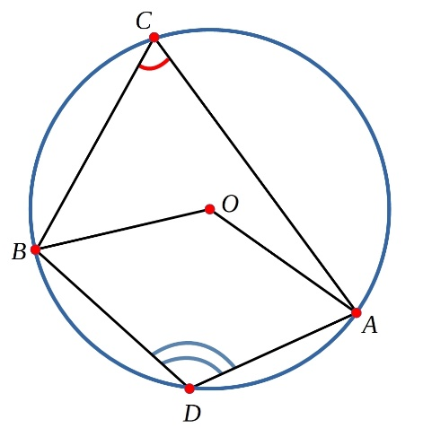
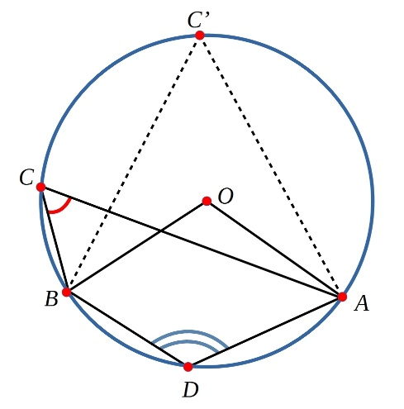
Can you show that the two angles marked in the diagram on the left add up to 180º? Can you use your results to show that the two angles marked in the diagram below add up to 180º?

